Descriptive Statistics

What is your educational qualification
 |  | Frequency | Percent | Valid Percent | Cumulative Percent
Valid | HND Holder | 5 | 7.7 | 7.7 | 7.7
Valid | HND holder plus professional ceryificate | 10 | 15.4 | 15.4 | 23.1
Valid | Degree holder | 33 | 50.8 | 50.8 | 73.8
Valid | Degree plus professional certification | 17 | 26.2 | 26.2 | 100.0
Valid | Total | 65 | 100.0 | 100.0

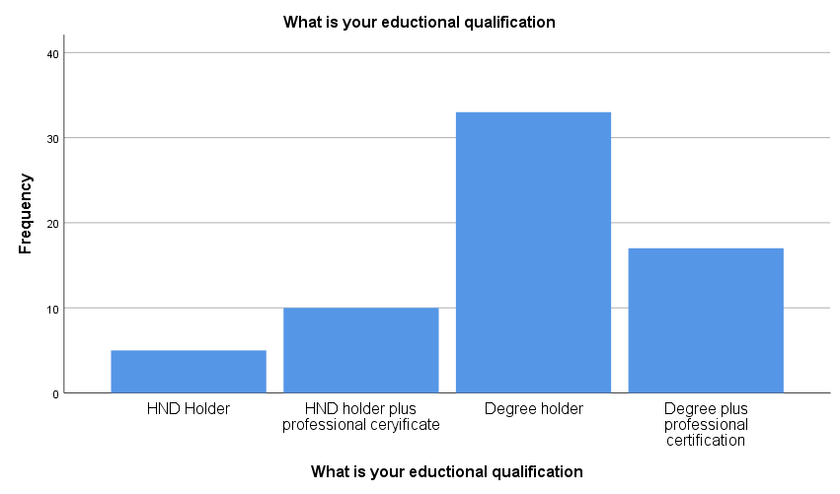

The bank can be characterised as possessing an adequate risk management framework
 |  | Frequency | Percent | Valid Percent | Cumulative Percent
Valid | strongly agree | 12 | 18.5 | 18.5 | 18.5
Valid | Agree | 40 | 61.5 | 61.5 | 80.0
Valid | Somewhat agree | 3 | 4.6 | 4.6 | 84.6
Valid | Neutral | 2 | 3.1 | 3.1 | 87.7
Valid | Somewhat Disagree | 2 | 3.1 | 3.1 | 90.8
Valid | Disagree | 3 | 4.6 | 4.6 | 95.4
Valid | Strongly Disagree | 3 | 4.6 | 4.6 | 100.0
Valid | Total | 65 | 100.0 | 100.0
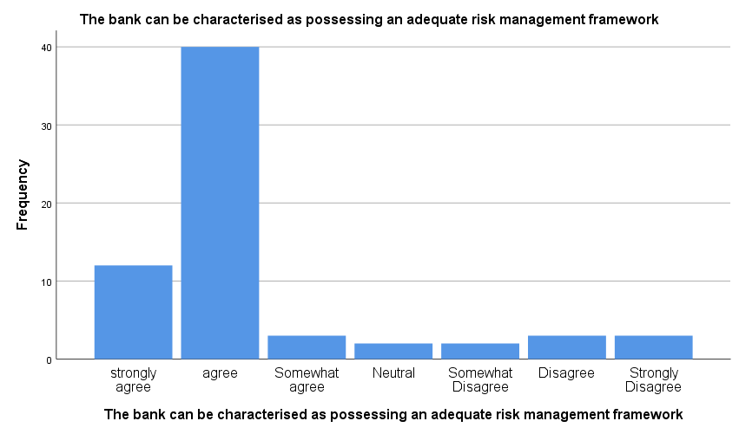

Current bank governance policies priorities the need of stakeholders
 |  | Frequency | Percent | Valid Percent | Cumulative Percent
Valid | strongly agree | 13 | 20.0 | 20.0 | 20.0
Valid | Agree | 27 | 41.5 | 41.5 | 61.5
Valid | Somewhat agree | 6 | 9.2 | 9.2 | 70.8
Valid | Neutral | 8 | 12.3 | 12.3 | 83.1
Valid | Somewhat Disagree | 3 | 4.6 | 4.6 | 87.7
Valid | Disagree | 5 | 7.7 | 7.7 | 95.4
Valid | Strongly Disagree | 3 | 4.6 | 4.6 | 100.0
Valid | Total | 65 | 100.0 | 100.0
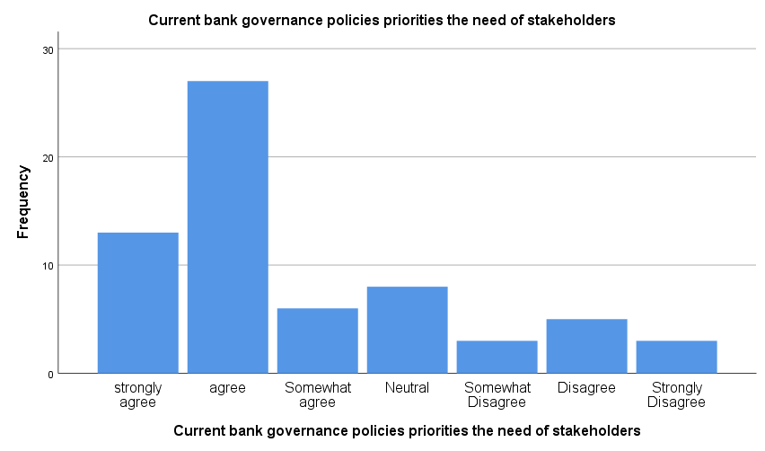

Outsiders and other stakeholders have influence over senior management
 |  | Frequency | Percent | Valid Percent | Cumulative Percent
Valid | strongly agree | 17 | 26.2 | 26.2 | 26.2
Valid | Agree | 23 | 35.4 | 35.4 | 61.5
Valid | Somewhat agree | 12 | 18.5 | 18.5 | 80.0
Valid | Neutral | 3 | 4.6 | 4.6 | 84.6
Valid | Somewhat Disagree | 3 | 4.6 | 4.6 | 89.2
Valid | Disagree | 3 | 4.6 | 4.6 | 93.8
Valid | Strongly Disagree | 4 | 6.2 | 6.2 | 100.0
Valid | Total | 65 | 100.0 | 100.0
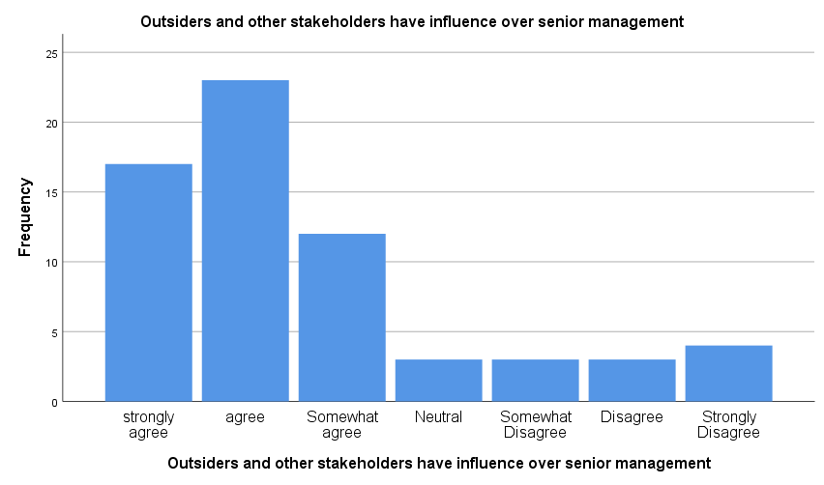

Managers in this bank tend to stair towards risks adverse investment
 |  | Frequency | Percent | Valid Percent | Cumulative Percent
Valid | strongly agree | 9 | 13.8 | 13.8 | 13.8
Valid | agree | 26 | 40.0 | 40.0 | 53.8
Valid | Somewhat agree | 10 | 15.4 | 15.4 | 69.2
Valid | Neutral | 2 | 3.1 | 3.1 | 72.3
Valid | Somewhat Disagree | 7 | 10.8 | 10.8 | 83.1
Valid | Disagree | 7 | 10.8 | 10.8 | 93.8
Valid | Strongly Disagree | 4 | 6.2 | 6.2 | 100.0
Valid | Total | 65 | 100.0 | 100.0
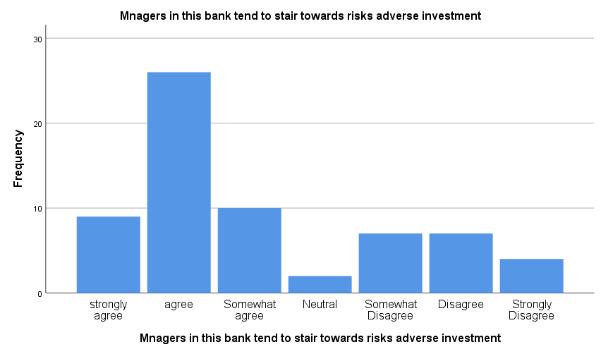

The board is capable of solving complex issues which is represented in management
 |  | Frequency | Percent | Valid Percent | Cumulative Percent
Valid | strongly agree | 12 | 18.5 | 18.5 | 18.5
Valid | agree | 32 | 49.2 | 49.2 | 67.7
Valid | Somewhat agree | 6 | 9.2 | 9.2 | 76.9
Valid | Neutral | 5 | 7.7 | 7.7 | 84.6
Valid | Somewhat Disagree | 3 | 4.6 | 4.6 | 89.2
Valid | Disagree | 3 | 4.6 | 4.6 | 93.8
Valid | Strongly Disagree | 4 | 6.2 | 6.2 | 100.0
Valid | Total | 65 | 100.0 | 100.0
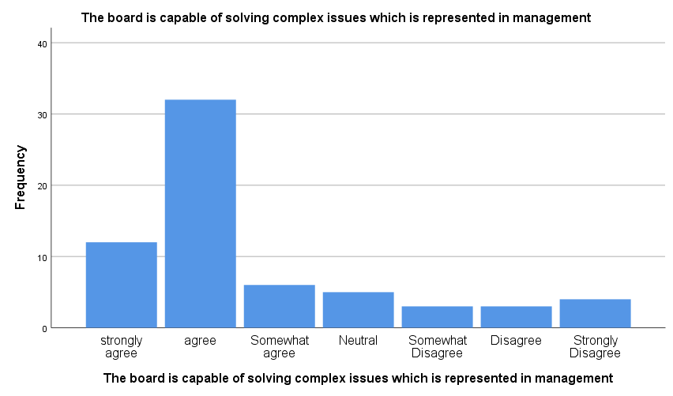

Members of the boards of the Directors in this banks are financial experts
 |  | Frequency | Percent | Valid Percent | Cumulative Percent
Valid | strongly agree | 8 | 12.3 | 12.3 | 12.3
Valid | agree | 36 | 55.4 | 55.4 | 67.7
Valid | Somewhat agree | 9 | 13.8 | 13.8 | 81.5
Valid | Neutral | 5 | 7.7 | 7.7 | 89.2
Valid | Somewhat Disagree | 2 | 3.1 | 3.1 | 92.3
Valid | Disagree | 2 | 3.1 | 3.1 | 95.4
Valid | Strongly Disagree | 3 | 4.6 | 4.6 | 100.0
Valid | Total | 65 | 100.0 | 100.0
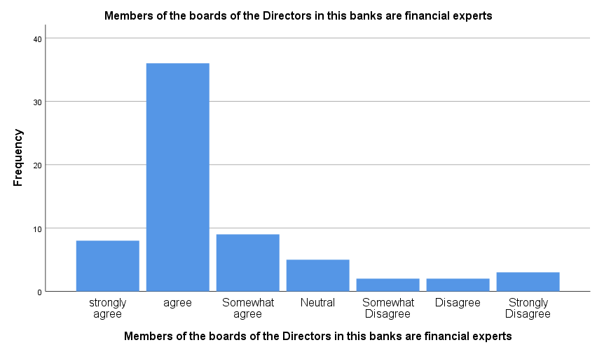

This bank exhibits proper risks management department and possesses a chief risk
 |  | Frequency | Percent | Valid Percent | Cumulative Percent
Valid | strongly agree | 7 | 10.8 | 10.8 | 10.8
Valid | agree | 32 | 49.2 | 49.2 | 60.0
Valid | Somewhat agree | 8 | 12.3 | 12.3 | 72.3
Valid | Neutral | 8 | 12.3 | 12.3 | 84.6
Valid | Somewhat Disagree | 8 | 12.3 | 12.3 | 96.9
Valid | Disagree | 1 | 1.5 | 1.5 | 98.5
Valid | Strongly Disagree | 1 | 1.5 | 1.5 | 100.0
Valid | Total | 65 | 100.0 | 100.0
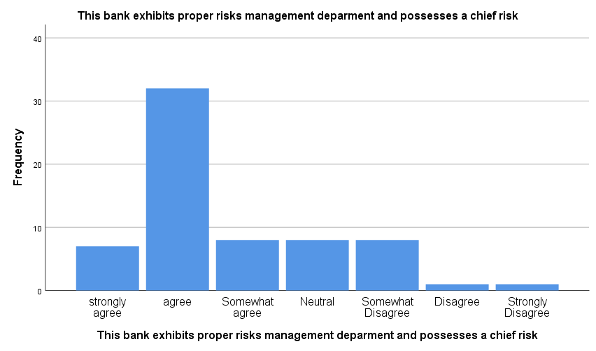

The audit committee board rather than board is responsible for this banks risk
 |  | Frequency | Percent | Valid Percent | Cumulative Percent
Valid | strongly agree | 7 | 10.8 | 10.8 | 10.8
Valid | agree | 30 | 46.2 | 46.2 | 56.9
Valid | Somewhat agree | 11 | 16.9 | 16.9 | 73.8
Valid | Neutral | 7 | 10.8 | 10.8 | 84.6
Valid | Somewhat Disagree | 3 | 4.6 | 4.6 | 89.2
Valid | Disagree | 4 | 6.2 | 6.2 | 95.4
Valid | Strongly Disagree | 3 | 4.6 | 4.6 | 100.0
Valid | Total | 65 | 100.0 | 100.0
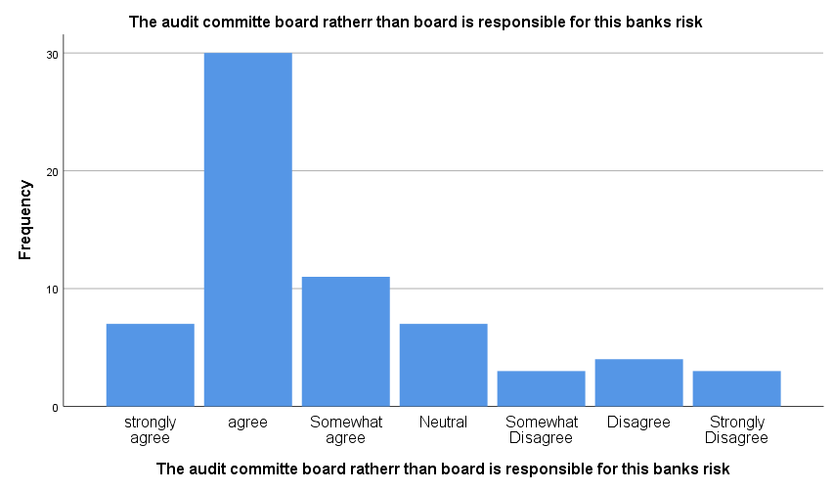

The audit committees in this banks may not posses the adequate expertise to interpret
 |  | Frequency | Percent | Valid Percent | Cumulative Percent
Valid | strongly agree | 4 | 6.2 | 6.2 | 6.2
Valid | agree | 34 | 52.3 | 52.3 | 58.5
Valid | Somewhat agree | 5 | 7.7 | 7.7 | 66.2
Valid | Neutral | 9 | 13.8 | 13.8 | 80.0
Valid | Somewhat Disagree | 4 | 6.2 | 6.2 | 86.2
Valid | Disagree | 5 | 7.7 | 7.7 | 93.8
Valid | Strongly Disagree | 4 | 6.2 | 6.2 | 100.0
Valid | Total | 65 | 100.0 | 100.0
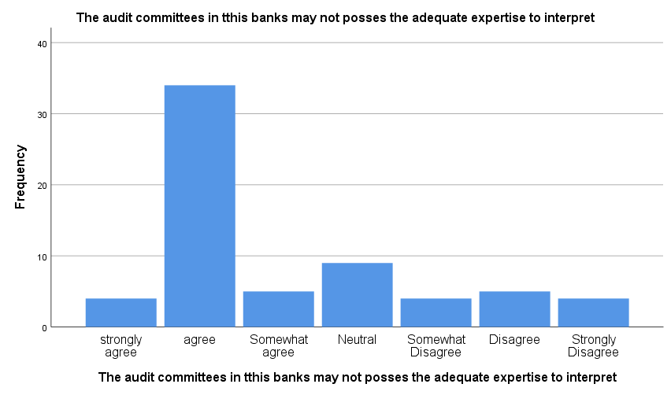

The audit committee in this banks is subject to undue influence by executive
 |  | Frequency | Percent | Valid Percent | Cumulative Percent
Valid | strongly agree | 3 | 4.6 | 4.6 | 4.6
Valid | agree | 3 | 4.6 | 4.6 | 9.2
Valid | Somewhat agree | 3 | 4.6 | 4.6 | 13.8
Valid | Neutral | 12 | 18.5 | 18.5 | 32.3
Valid | Somewhat Disagree | 23 | 35.4 | 35.4 | 67.7
Valid | Disagree | 21 | 32.3 | 32.3 | 100.0
Valid | Total | 65 | 100.0 | 100.0
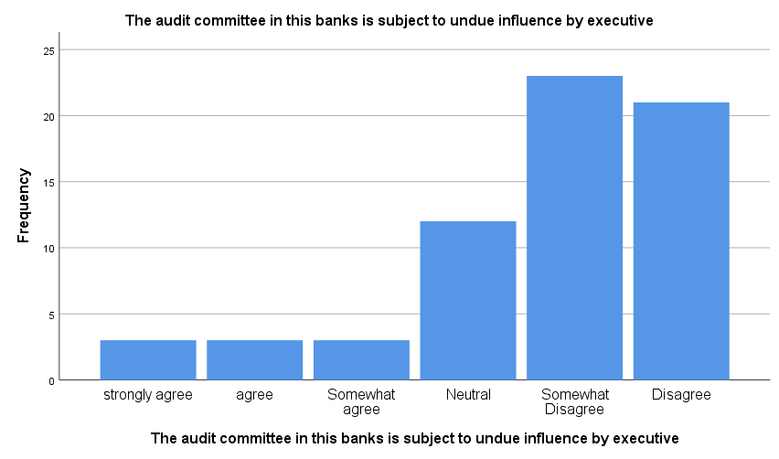

This bank is characterised by lack of information transparency
 |  | Frequency | Percent | Valid Percent | Cumulative Percent
Valid | strongly agree | 3 | 4.6 | 4.6 | 4.6
Valid | agree | 3 | 4.6 | 4.6 | 9.2
Valid | Somewhat agree | 4 | 6.2 | 6.2 | 15.4
Valid | Neutral | 9 | 13.8 | 13.8 | 29.2
Valid | Somewhat Disagree | 30 | 46.2 | 46.2 | 75.4
Valid | Disagree | 11 | 16.9 | 16.9 | 92.3
Valid | Strongly Disagree | 5 | 7.7 | 7.7 | 100.0
Valid | Total | 65 | 100.0 | 100.0

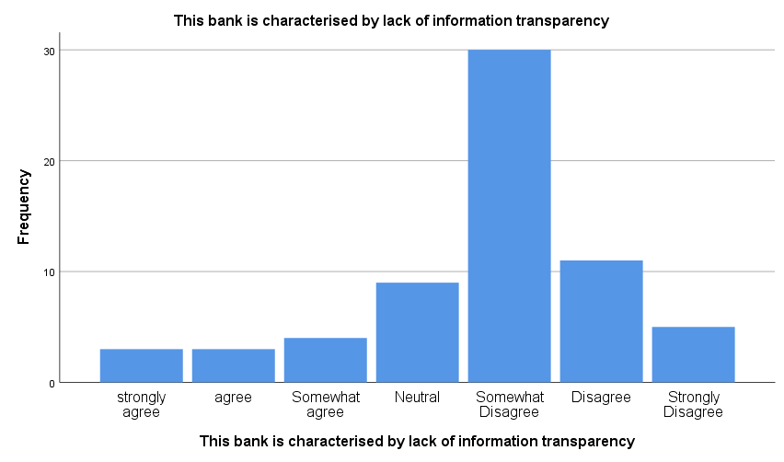
There are falsification of financial statement to regulatory authorities in this bank
 |  | Frequency | Percent | Valid Percent | Cumulative Percent
Valid | strongly agree | 3 | 4.6 | 4.6 | 4.6
Valid | agree | 3 | 4.6 | 4.6 | 9.2
Valid | Neutral | 1 | 1.5 | 1.5 | 10.8
Valid | Somewhat Disagree | 30 | 46.2 | 46.2 | 56.9
Valid | Disagree | 18 | 27.7 | 27.7 | 84.6
Valid | Strongly Disagree | 10 | 15.4 | 15.4 | 100.0
Valid | Total | 65 | 100.0 | 100.0
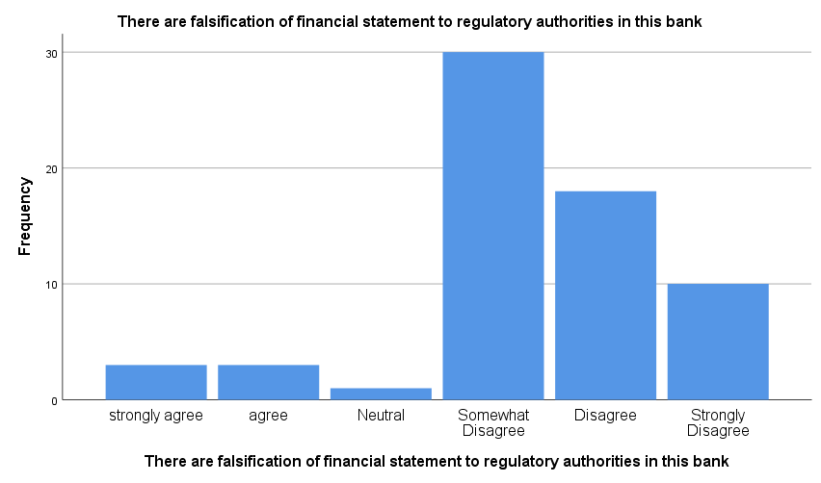

It is challenging for this banks to implement effective corporate governance mechanisms to mitigate the risk
 |  | Frequency | Percent | Valid Percent | Cumulative Percent
Valid | strongly agree | 2 | 3.1 | 3.1 | 3.1
Valid | agree | 3 | 4.6 | 4.6 | 7.7
Valid | Somewhat agree | 3 | 4.6 | 4.6 | 12.3
Valid | Neutral | 7 | 10.8 | 10.8 | 23.1
Valid | Somewhat Disagree | 10 | 15.4 | 15.4 | 38.5
Valid | Disagree | 32 | 49.2 | 49.2 | 87.7
Valid | Strongly Disagree | 8 | 12.3 | 12.3 | 100.0
Valid | Total | 65 | 100.0 | 100.0

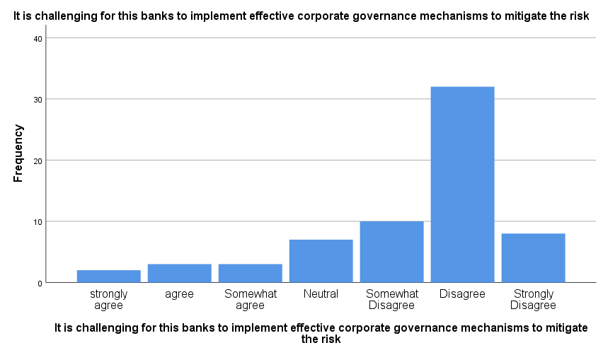
The Board of Directors lack monitoring and oversight of this banks managers
 |  | Frequency | Percent | Valid Percent | Cumulative Percent
Valid | strongly agree | 3 | 4.6 | 4.6 | 4.6
Valid | agree | 3 | 4.6 | 4.6 | 9.2
Valid | Somewhat agree | 3 | 4.6 | 4.6 | 13.8
Valid | Neutral | 6 | 9.2 | 9.2 | 23.1
Valid | Somewhat Disagree | 19 | 29.2 | 29.2 | 52.3
Valid | Disagree | 28 | 43.1 | 43.1 | 95.4
Valid | Strongly Disagree | 3 | 4.6 | 4.6 | 100.0
Valid | Total | 65 | 100.0 | 100.0
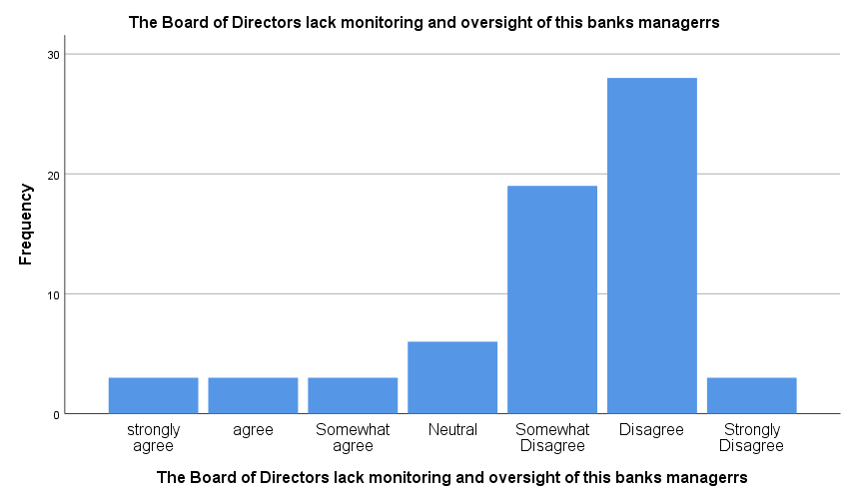

This banks director is characterised with lack of expertise
 |  | Frequency | Percent | Valid Percent | Cumulative Percent
Valid | strongly agree | 2 | 3.1 | 3.1 | 3.1
Valid | agree | 2 | 3.1 | 3.1 | 6.2
Valid | Somewhat agree | 2 | 3.1 | 3.1 | 9.2
Valid | Neutral | 36 | 55.4 | 55.4 | 64.6
Valid | Somewhat Disagree | 8 | 12.3 | 12.3 | 76.9
Valid | Disagree | 15 | 23.1 | 23.1 | 100.0
Valid | Total | 65 | 100.0 | 100.0
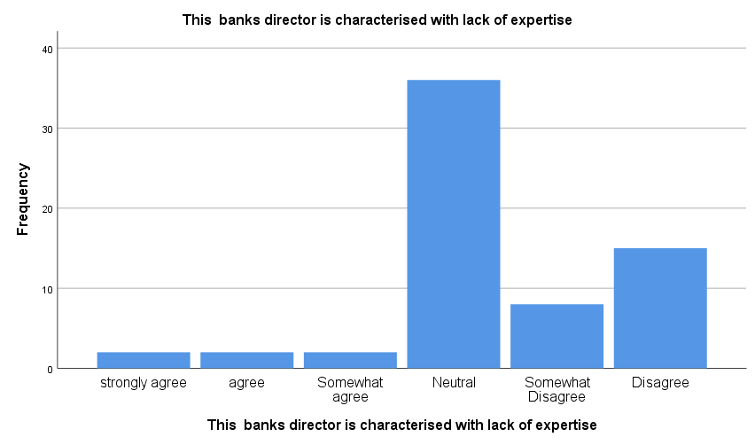

This banks directors is characterised with lack of expertise due to influence by the concentrated ownership structures of this banks shareholders
 |  | Frequency | Percent | Valid Percent | Cumulative Percent
Valid | strongly agree | 2 | 3.1 | 3.1 | 3.1
Valid | agree | 3 | 4.6 | 4.6 | 7.7
Valid | Somewhat agree | 3 | 4.6 | 4.6 | 12.3
Valid | Neutral | 10 | 15.4 | 15.4 | 27.7
Valid | Somewhat Disagree | 20 | 30.8 | 30.8 | 58.5
Valid | Disagree | 19 | 29.2 | 29.2 | 87.7
Valid | Strongly Disagree | 8 | 12.3 | 12.3 | 100.0
Valid | Total | 65 | 100.0 | 100.0
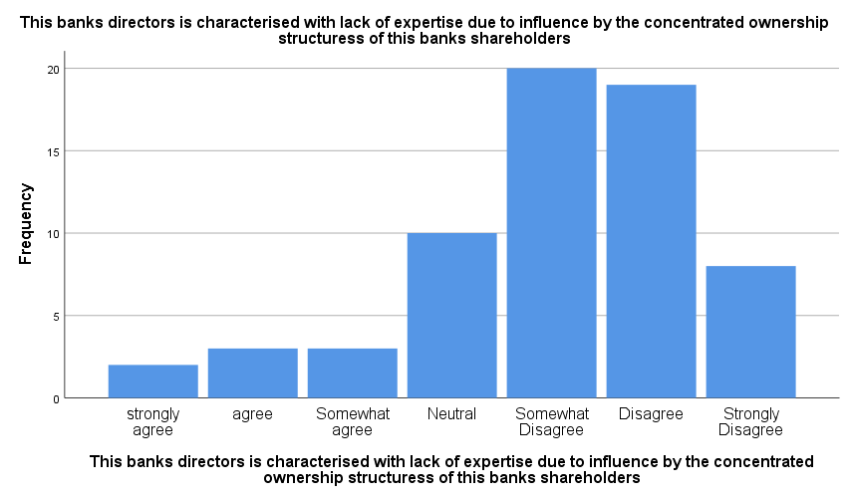

Unjust enrichment is prevalent through the use of special purpose vehicles misuse depositors funds
 |  | Frequency | Percent | Valid Percent | Cumulative Percent
Valid | strongly agree | 1 | 1.5 | 1.5 | 1.5
Valid | agree | 3 | 4.6 | 4.6 | 6.2
Valid | Somewhat agree | 3 | 4.6 | 4.6 | 10.8
Valid | Neutral | 23 | 35.4 | 35.4 | 46.2
Valid | Somewhat Disagree | 10 | 15.4 | 15.4 | 61.5
Valid | Disagree | 12 | 18.5 | 18.5 | 80.0
Valid | Strongly Disagree | 13 | 20.0 | 20.0 | 100.0
Valid | Total | 65 | 100.0 | 100.0
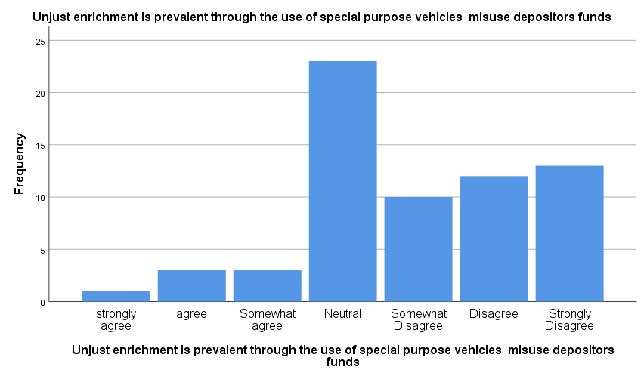

Managers engage in self-interested behaviour that may be detrimental to the survival of this bank
 |  | Frequency | Percent | Valid Percent | Cumulative Percent
Valid | strongly agree | 3 | 4.6 | 4.6 | 4.6
Valid | agree | 3 | 4.6 | 4.6 | 9.2
Valid | Neutral | 1 | 1.5 | 1.5 | 10.8
Valid | Somewhat Disagree | 26 | 40.0 | 40.0 | 50.8
Valid | Disagree | 29 | 44.6 | 44.6 | 95.4
Valid | Strongly Disagree | 3 | 4.6 | 4.6 | 100.0
Valid | Total | 65 | 100.0 | 100.0

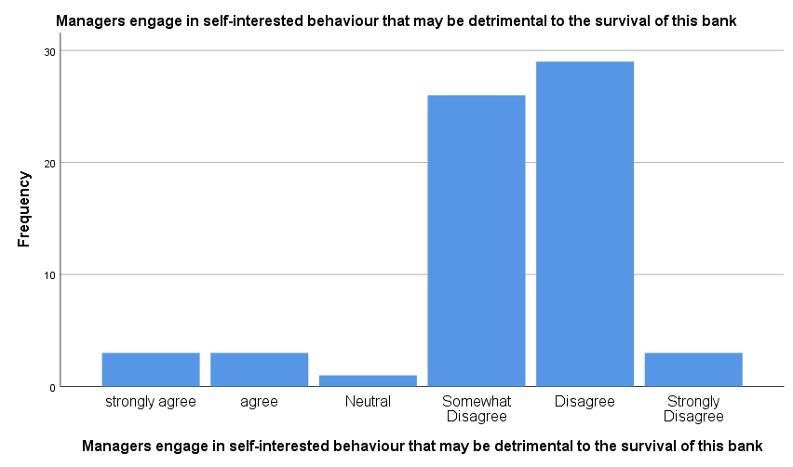
Adverse selection of borrowers is a feature of this bank
 |  | Frequency | Percent | Valid Percent | Cumulative Percent
Valid | strongly agree | 1 | 1.5 | 1.5 | 1.5
Valid | agree | 2 | 3.1 | 3.1 | 4.6
Valid | Neutral | 22 | 33.8 | 33.8 | 38.5
Valid | Disagree | 33 | 50.8 | 50.8 | 89.2
Valid | Strongly Disagree | 7 | 10.8 | 10.8 | 100.0
Valid | Total | 65 | 100.0 | 100.0
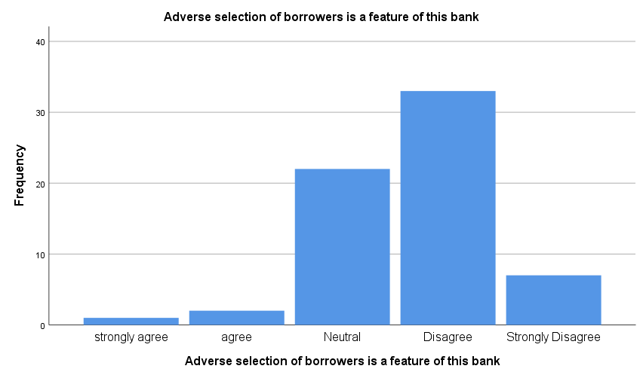

This banks attempts to lure consumers away from competitors by offering lower interest rate leading to an overall decrease in the loan portfolio
 |  | Frequency | Percent | Valid Percent | Cumulative Percent
Valid | agree | 1 | 1.5 | 1.5 | 1.5
Valid | Neutral | 25 | 38.5 | 38.5 | 40.0
Valid | Somewhat Disagree | 16 | 24.6 | 24.6 | 64.6
Valid | Disagree | 23 | 35.4 | 35.4 | 100.0
Valid | Total | 65 | 100.0 | 100.0

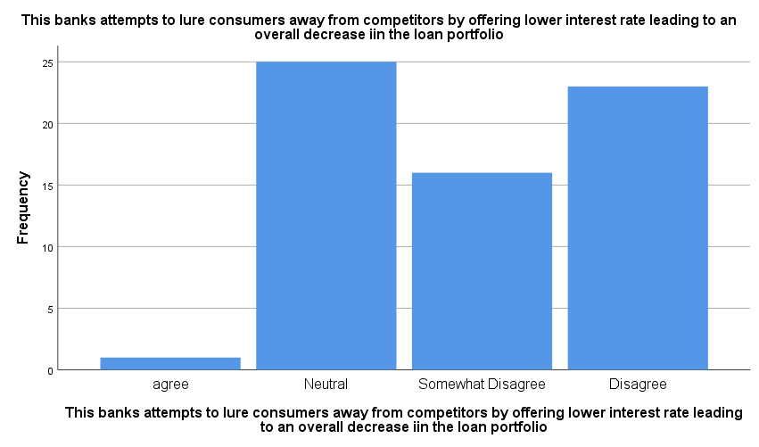
Banking requlation are enforced effectively in the bank
 |  | Frequency | Percent | Valid Percent | Cumulative Percent
Valid | strongly agree | 18 | 27.7 | 27.7 | 27.7
Valid | agree | 17 | 26.2 | 26.2 | 53.8
Valid | Somewhat agree | 10 | 15.4 | 15.4 | 69.2
Valid | Neutral | 12 | 18.5 | 18.5 | 87.7
Valid | Somewhat Disagree | 3 | 4.6 | 4.6 | 92.3
Valid | Disagree | 3 | 4.6 | 4.6 | 96.9
Valid | Strongly Disagree | 2 | 3.1 | 3.1 | 100.0
Valid | Total | 65 | 100.0 | 100.0
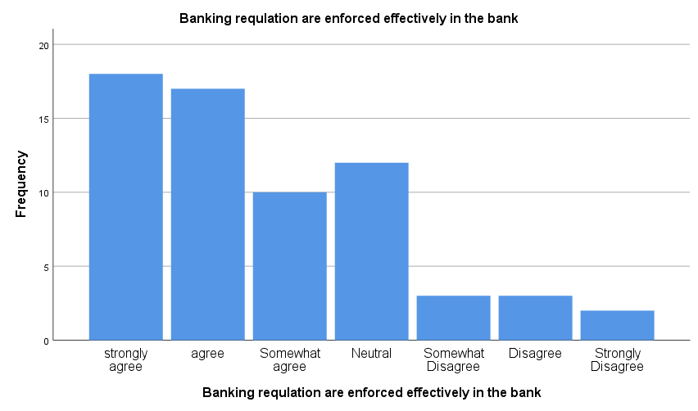

Nigeria lacks an effectives judicial system to enforce banking regulations
 |  | Frequency | Percent | Valid Percent | Cumulative Percent
Valid | strongly agree | 3 | 4.6 | 4.6 | 4.6
Valid | agree | 11 | 16.9 | 16.9 | 21.5
Valid | Somewhat agree | 16 | 24.6 | 24.6 | 46.2
Valid | Somewhat Disagree | 2 | 3.1 | 3.1 | 49.2
Valid | Disagree | 33 | 50.8 | 50.8 | 100.0
Valid | Total | 65 | 100.0 | 100.0

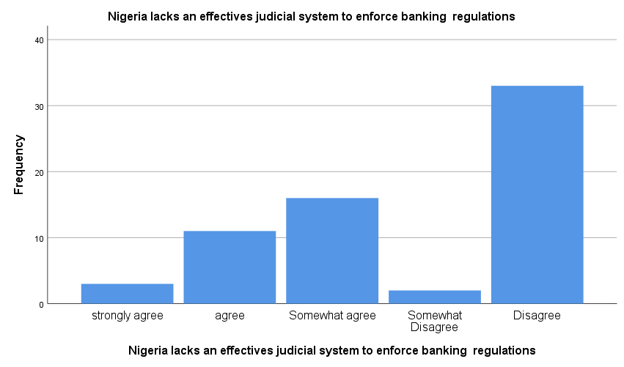
corporate governance guidelines are clear within you bank and outlines acceptable
 |  | Frequency | Percent | Valid Percent | Cumulative Percent
Valid | strongly agree | 24 | 36.9 | 36.9 | 36.9
Valid | agree | 33 | 50.8 | 50.8 | 87.7
Valid | Neutral | 3 | 4.6 | 4.6 | 92.3
Valid | Somewhat Disagree | 1 | 1.5 | 1.5 | 93.8
Valid | Disagree | 1 | 1.5 | 1.5 | 95.4
Valid | Strongly Disagree | 3 | 4.6 | 4.6 | 100.0
Valid | Total | 65 | 100.0 | 100.0
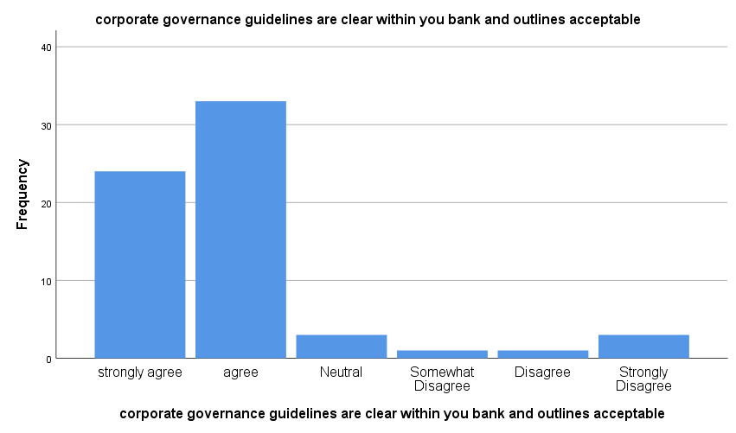

Corporate governance legislation reflects the Country specific need
 |  | Frequency | Percent | Valid Percent | Cumulative Percent
Valid | strongly agree | 7 | 10.8 | 10.8 | 10.8
Valid | Agree | 41 | 63.1 | 63.1 | 73.8
Valid | Somewhat agree | 8 | 12.3 | 12.3 | 86.2
Valid | Somewhat Disagree | 3 | 4.6 | 4.6 | 90.8
Valid | Disagree | 4 | 6.2 | 6.2 | 96.9
Valid | Strongly Disagree | 2 | 3.1 | 3.1 | 100.0
Valid | Total | 65 | 100.0 | 100.0
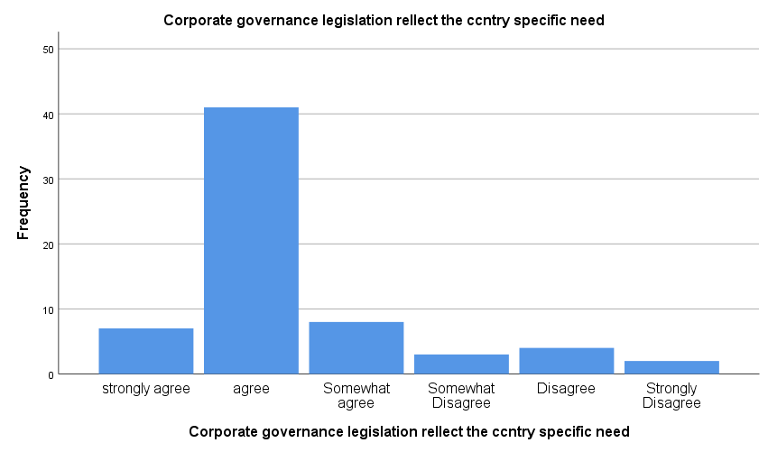

there is confusion resulting from the abundance of corporate governance codes in the country
 |  | Frequency | Percent | Valid Percent | Cumulative Percent
Valid | strongly agree | 17 | 26.2 | 26.2 | 26.2
Valid | Agree | 44 | 67.7 | 67.7 | 93.8
Valid | Somewhat Disagree | 1 | 1.5 | 1.5 | 95.4
Valid | Disagree | 3 | 4.6 | 4.6 | 100.0
Valid | Total | 65 | 100.0 | 100.0
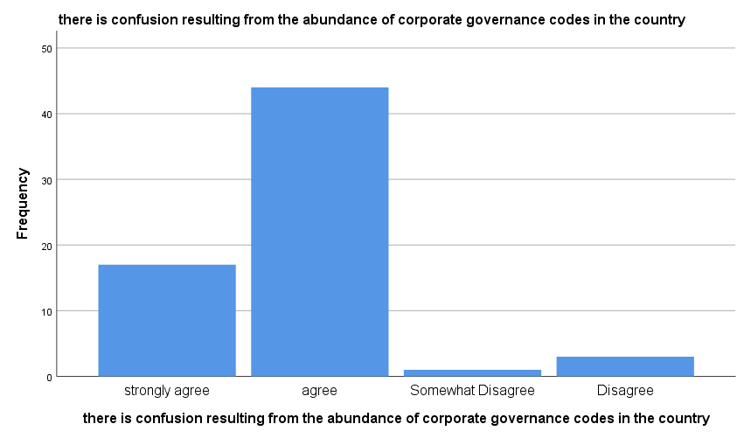

Multiple self-regulatory codes create an environment of uncertainty and lack of cohesion in the banking industry
 |  | Frequency | Percent | Valid Percent | Cumulative Percent
Valid | strongly agree | 18 | 27.7 | 27.7 | 27.7
Valid | agree | 44 | 67.7 | 67.7 | 95.4
Valid | Somewhat agree | 1 | 1.5 | 1.5 | 96.9
Valid | Somewhat Disagree | 1 | 1.5 | 1.5 | 98.5
Valid | Disagree | 1 | 1.5 | 1.5 | 100.0
Valid | Total | 65 | 100.0 | 100.0
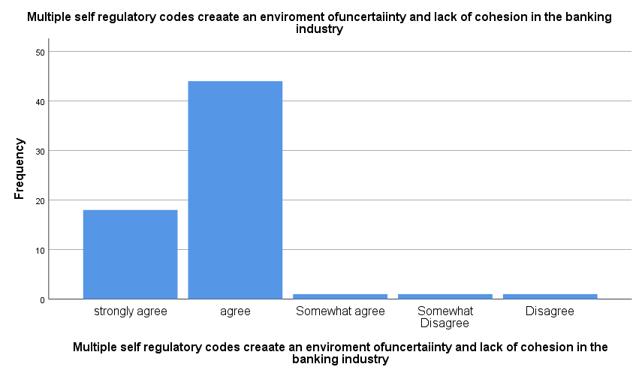

Abundance of governance codes lead to uncertainty wreak enforcement and difficulty in distinguishing between bank that comply with good governance practice and those that do
 |  | Frequency | Percent | Valid Percent | Cumulative Percent
Valid | strongly agree | 8 | 12.3 | 12.3 | 12.3
Valid | agree | 15 | 23.1 | 23.1 | 35.4
Valid | Somewhat agree | 16 | 24.6 | 24.6 | 60.0
Valid | Neutral | 26 | 40.0 | 40.0 | 100.0
Valid | Total | 65 | 100.0 | 100.0

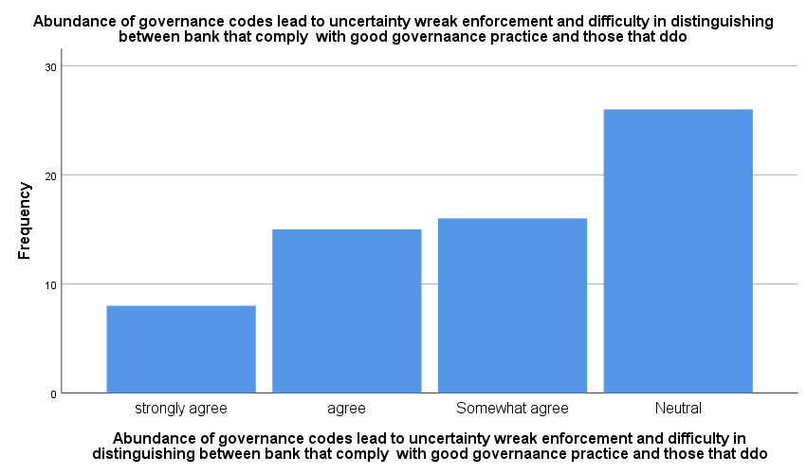

The audit process in this bank is transparent
 |  | Frequency | Percent | Valid Percent | Cumulative Percent
Valid | Extremely high | 6 | 9.2 | 9.2 | 9.2
Valid | high | 22 | 33.8 | 33.8 | 43.1
Valid | Average | 37 | 56.9 | 56.9 | 100.0
Valid | Total | 65 | 100.0 | 100.0
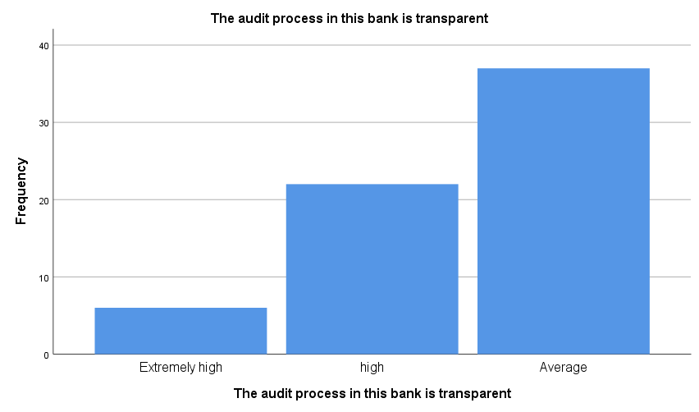

The board of directors hold themselves accountable in regard to corporate governance practices
 |  | Frequency | Percent | Valid Percent | Cumulative Percent
Valid | Extremely high | 4 | 6.2 | 6.2 | 6.2
Valid | high | 47 | 72.3 | 72.3 | 78.5
Valid | Average | 14 | 21.5 | 21.5 | 100.0
Valid | Total | 65 | 100.0 | 100.0
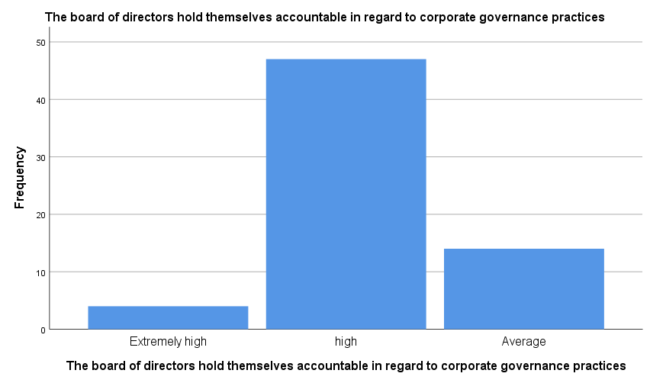

Who is in charge of yours board
 |  | Frequency | Percent | Valid Percent | Cumulative Percent
Valid | CEO | 2 | 3.1 | 3.1 | 3.1
Valid | Government | 2 | 3.1 | 3.1 | 6.2
Valid | Board | 59 | 90.8 | 90.8 | 96.9
Valid | Manager | 2 | 3.1 | 3.1 | 100.0
Valid | Total | 65 | 100.0 | 100.0

